

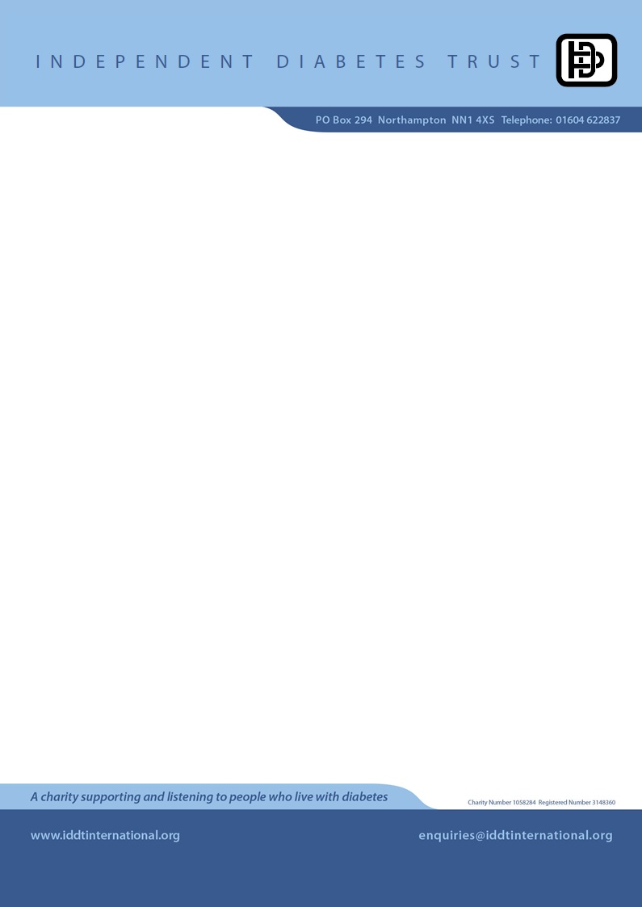
PRESS RELEASE
DAY, DATE MONTH, 2014

LOCATION MAN/WOMAN takes on challenge for diabetes charity

A TOWN/VILLAGE MAN/WOMAN has taken on a fundraising challenge to celebrate a diabetes charity’s 20-year anniversary.

YOUR NAME is going to DETAILS OF YOUR CHALLENGE for the Independent Diabetes Trust (IDDT), which has launched its £20 challenge in a bid to generate much-needed funds by calling on every supporter to raise an ‘attainable’ amount.

The YOUR AGE-year-old, of STREET NAME, is in TRAINING/PREPARATION ahead of the FURTHER DETAILS OF YOUR CHALLENGE.

YOUR NAME said: “The IDDT work tirelessly in the name of people with diabetes, helping to make their lives easier. I am a dedicated supporter and am proud to be taking on this challenge.

“EXTRA DETAILS AND YOUR OPINIONS ABOUT YOUR CHALLENGE.”

The Northampton-based charity has launched the campaign to help guarantee the continuation of its work providing vital independent support for people with diabetes, their parents and carers.

The charity formed in 1994 to fight for choice of insulin for all. It now provides a free, confidential helpline, has published dozens of helpful publications, stages events and lobbies the government on behalf of its members.

It is estimated that more than one in 20 people in the UK has diabetes (diagnosed or undiagnosed). There are 2.9 million people who have been diagnosed with diabetes in the UK¹. By 2025, it is estimated five million people will have diabetes in the UK².

Martin Hirst, acting IDDT chief executive, said: “Diabetes is quickly becoming the health epidemic of the 21st century. We need to take diabetes seriously before it causes more problems to more people.

“We, like every charity, are reliant on donations but whereas other fundraising drives can be quite demanding, our £20 challenge is attainable for both our challengers and sponsors.”

For more information about the IDDT, visit: www.iddt.org. To sponsor YOUR NAME, visit: YOUR JUST GIVING LINK or email YOUR EMAIL ADDRESS or call YOUR PHONE NUMBER.

- ends -

Notes to Editors
The Trust produces a wide variety of free information and is reliant totally on voluntary donations.

For more information about the work of the Trust, contact:
Telephone: 01604 622837
Email: martin@iddtinternational.org

For press details please contact:
Veronica Wray PR
Telephone: 020 8568 8546
Mobile: 07710 624454
Email: info@veronicawray.com

- Quality and outcomes framework (QOF) 2011: England: http://bit.ly/qof2011e,
Northern Ireland: http://bit.ly/qof2011ni ,Scotland: http://bit.ly/qof2011s, Wales: http://bit.ly/qof2011w
- Figures based on AHPO diabetes prevalence model: http://bit.ly/aphodiabetes
The APHO model estimates that by 2025 there will be 4,189,229 million people with diabetes in England, 371,310 people in Scotland, and 287,929 people in Wales. The model was not used to give a 2025 prediction for Northern Ireland so we are using the current APHO model estimate total for diagnosed and undiagnosed for 2010 of 109,000 [unpublished]. Adding these up gives us the estimate of five million people with diabetes in 2025.

